**Network Analysis**

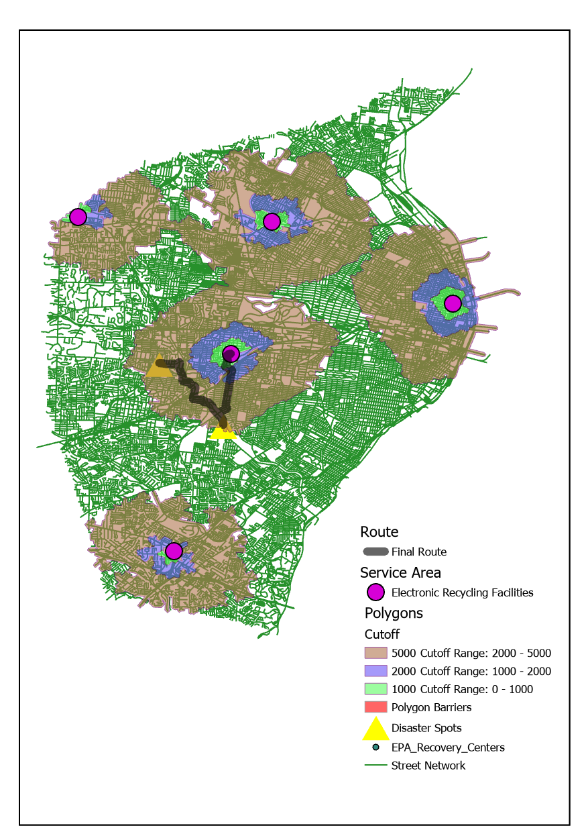

**Figure 1**

The map reflects outputs from exercise directions such as filtered electronic recycling facilities, service area polygons and final route.

**Figure 2**

Figure 2 indicates change in route when a line barrier was impacting the route.